**DAILY ONLINE ACTIVITIES SUMMARY**

|  |  |  |  |  |  |  |  |  |
| --- | --- | --- | --- | --- | --- | --- | --- | --- |
| **Date:** | **02/07/2020** | | | | | **Name:** | **Katira Krishna J** | |
| **Sem & Sec** | **8th A** | | | | | **USN:** | **4AL16CS045** | |
| **Online Test Summary** | | | | | | | | |
| **Subject** | | **SMS** | | | | | | |
| **Max. Marks** | | **30** | | **Score** | | | **Not attended** | |
| **Certification Course Summary** | | | | | | | | |
| **Course** | **Accelerating Deep Learning with GPU** | | | | | | | |
| **Certificate Provider** | | | **Cognitiveclass.ai** | | **Duration** | | | **5 hours** |
| **Coding Challenges** | | | | | | | | |
| **Problem Statement: Python program to append, delete and display elements of a list using classes** | | | | | | | | |
| **Status: Completed** | | | | | | | | |
| **Uploaded the report in Github** | | | | | **Yes** | | | |
| **If yes Repository name** | | | | | **Krishna_Katira** | | | |
| **Uploaded the report in slack** | | | | | **Yes** | | | |

Online Test Details:

Not attended

Certification Course Details:

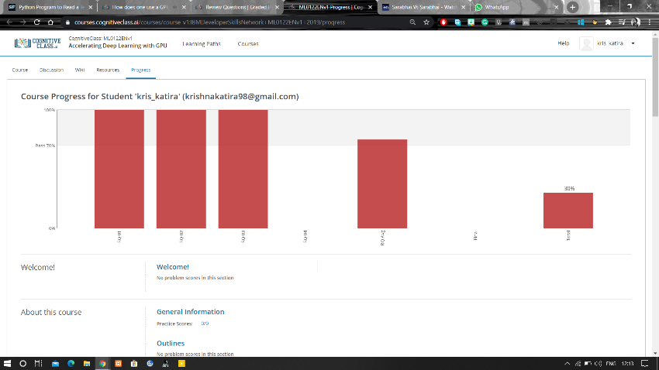

Coding Challenges Details:

**Program:**

class check():

def __init__(self):

self.n=[]

def add(self,a):

return self.n.append(a)

def remove(self,b):

self.n.remove(b)

def dis(self):

return (self.n)

obj=check()

choice=1

while choice!=0:

print("0. Exit")

print("1. Add")

print("2. Delete")

print("3. Display")

choice=int(input("Enter choice: "))

if choice==1:

n=int(input("Enter number to append: "))

obj.add(n)

print("List: ",obj.dis())

elif choice==2:

n=int(input("Enter number to remove: "))

obj.remove(n)

print("List: ",obj.dis())

elif choice==3:

print("List: ",obj.dis())

elif choice==0:

print("Exiting!")

else:

print("Invalid choice!!")

print()